Functional model of the hybrid electric-air drive
Juraj ONDRUŠKA¹, Jozef Babics ¹, Lubomír ŠOOŠ ¹, Iveta ONDEROVÁ ¹

- Slovak University of Technology in Bratislava, Faculty of Mechanical Engineering, Námestie Slobody 17, 812 31 Bratislava, Slovak Republic
Abstract
For a better understanding and digitization of operating states, spinning spindles, we needed to carry out a series of advanced measurements. As part of this task, we completed a prototype of a test device to verify the performance of an electro-pneumatic hybrid drive. The basic device consists of a rotor bearing on which is a series-connected electric motor with a continuous shaft on which is a series-connected pneumatic drive. The device is equipped with a battery power supply, with complex start-up control, and with an output-input data logger of the electrical part of the drive. Total drive speed was measured electromagnetically by the electric motor control and verified by an optical tachometer that senses the reflection point. From the test results, it is possible to determine the expected characteristics of the new hybrid drive as well as to determine the benefits of such a hybrid arrangement. For further development steps it is necessary to specify the technical requirements for the pneumatic drive circuit or optimize its design. The device, after further modifications, allows to derive the effects of secondary cooling in terms of the overall energy balance of the new hybrid drive design. This prototype also has a perspective in terms of testing and optimizing new bearing configurations and innovative electrical and mechanical hybrid drive elements. Currently, we are engaged in overall optimization of individual parts of the device based on existing test results.

Keywords: spinning machine, loading, progressive design, high speed rotor, analysis

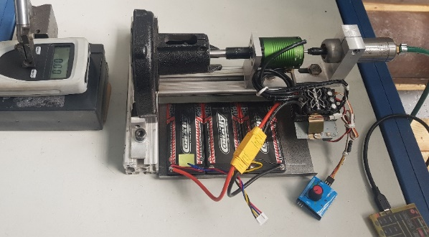
Functional model of hybrid drive
Acknowledgment
The research presented in this paper is an outcome of the project No. APVV-16-0476 “ Research and development of the progressive design of the high speed rotor mounting in spinning machine.” funded by the Slovak Research and Development Agency and No. SK-PL-18-0075“ NFLUENCE OF THERMAL CONDITIONS OF HEATING AND MOISTURE CONTENT ON MECHANICAL AND ENERGY PROPERTIES OF BIOMASS PELLET “ funded by the Slovak Research and Development Agency.

